
QUALITY ALERT

Customer: ChamClad Date: March 15, 2025
Die: 15766 Customer NCR:
Type of Complaint: ChamClad REJECT

Description: ChamClad REJECTED due to bump edge causing bubbles/defects on lamination.
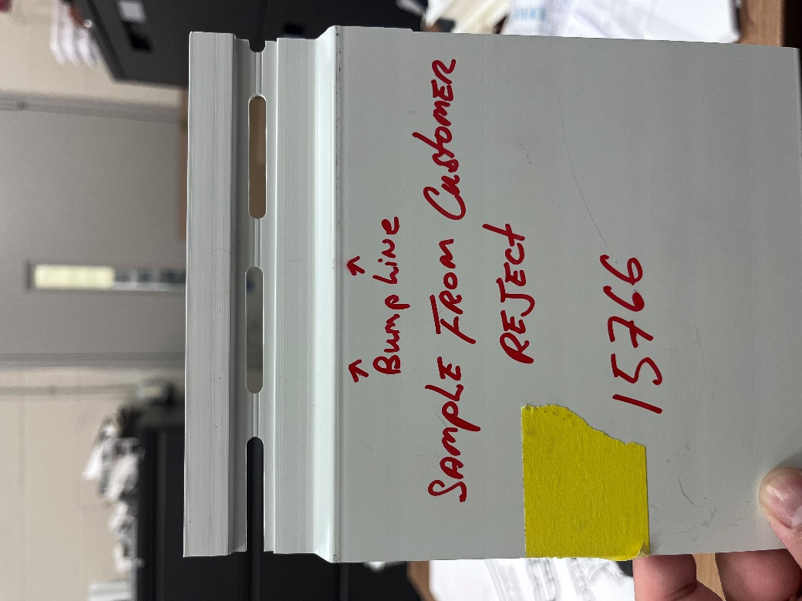

PLEASE MAKE SURE SURFACE IS SMOOTH BEFORE PACKING
BY SIGNING BELOW, YOU ACKNOWLEDGE THE PROBLEM ABOVE AND AGREE TO MONITOR THIS ISSUE IN FUTURE PRODUCTION RUNS.
DAY SHIFT |  | AFTERNOON SHIFT |  | NIGHT SHIFT
NAME | SIGNATURE | NAME | SIGNATURE | NAME | SIGNATURE

